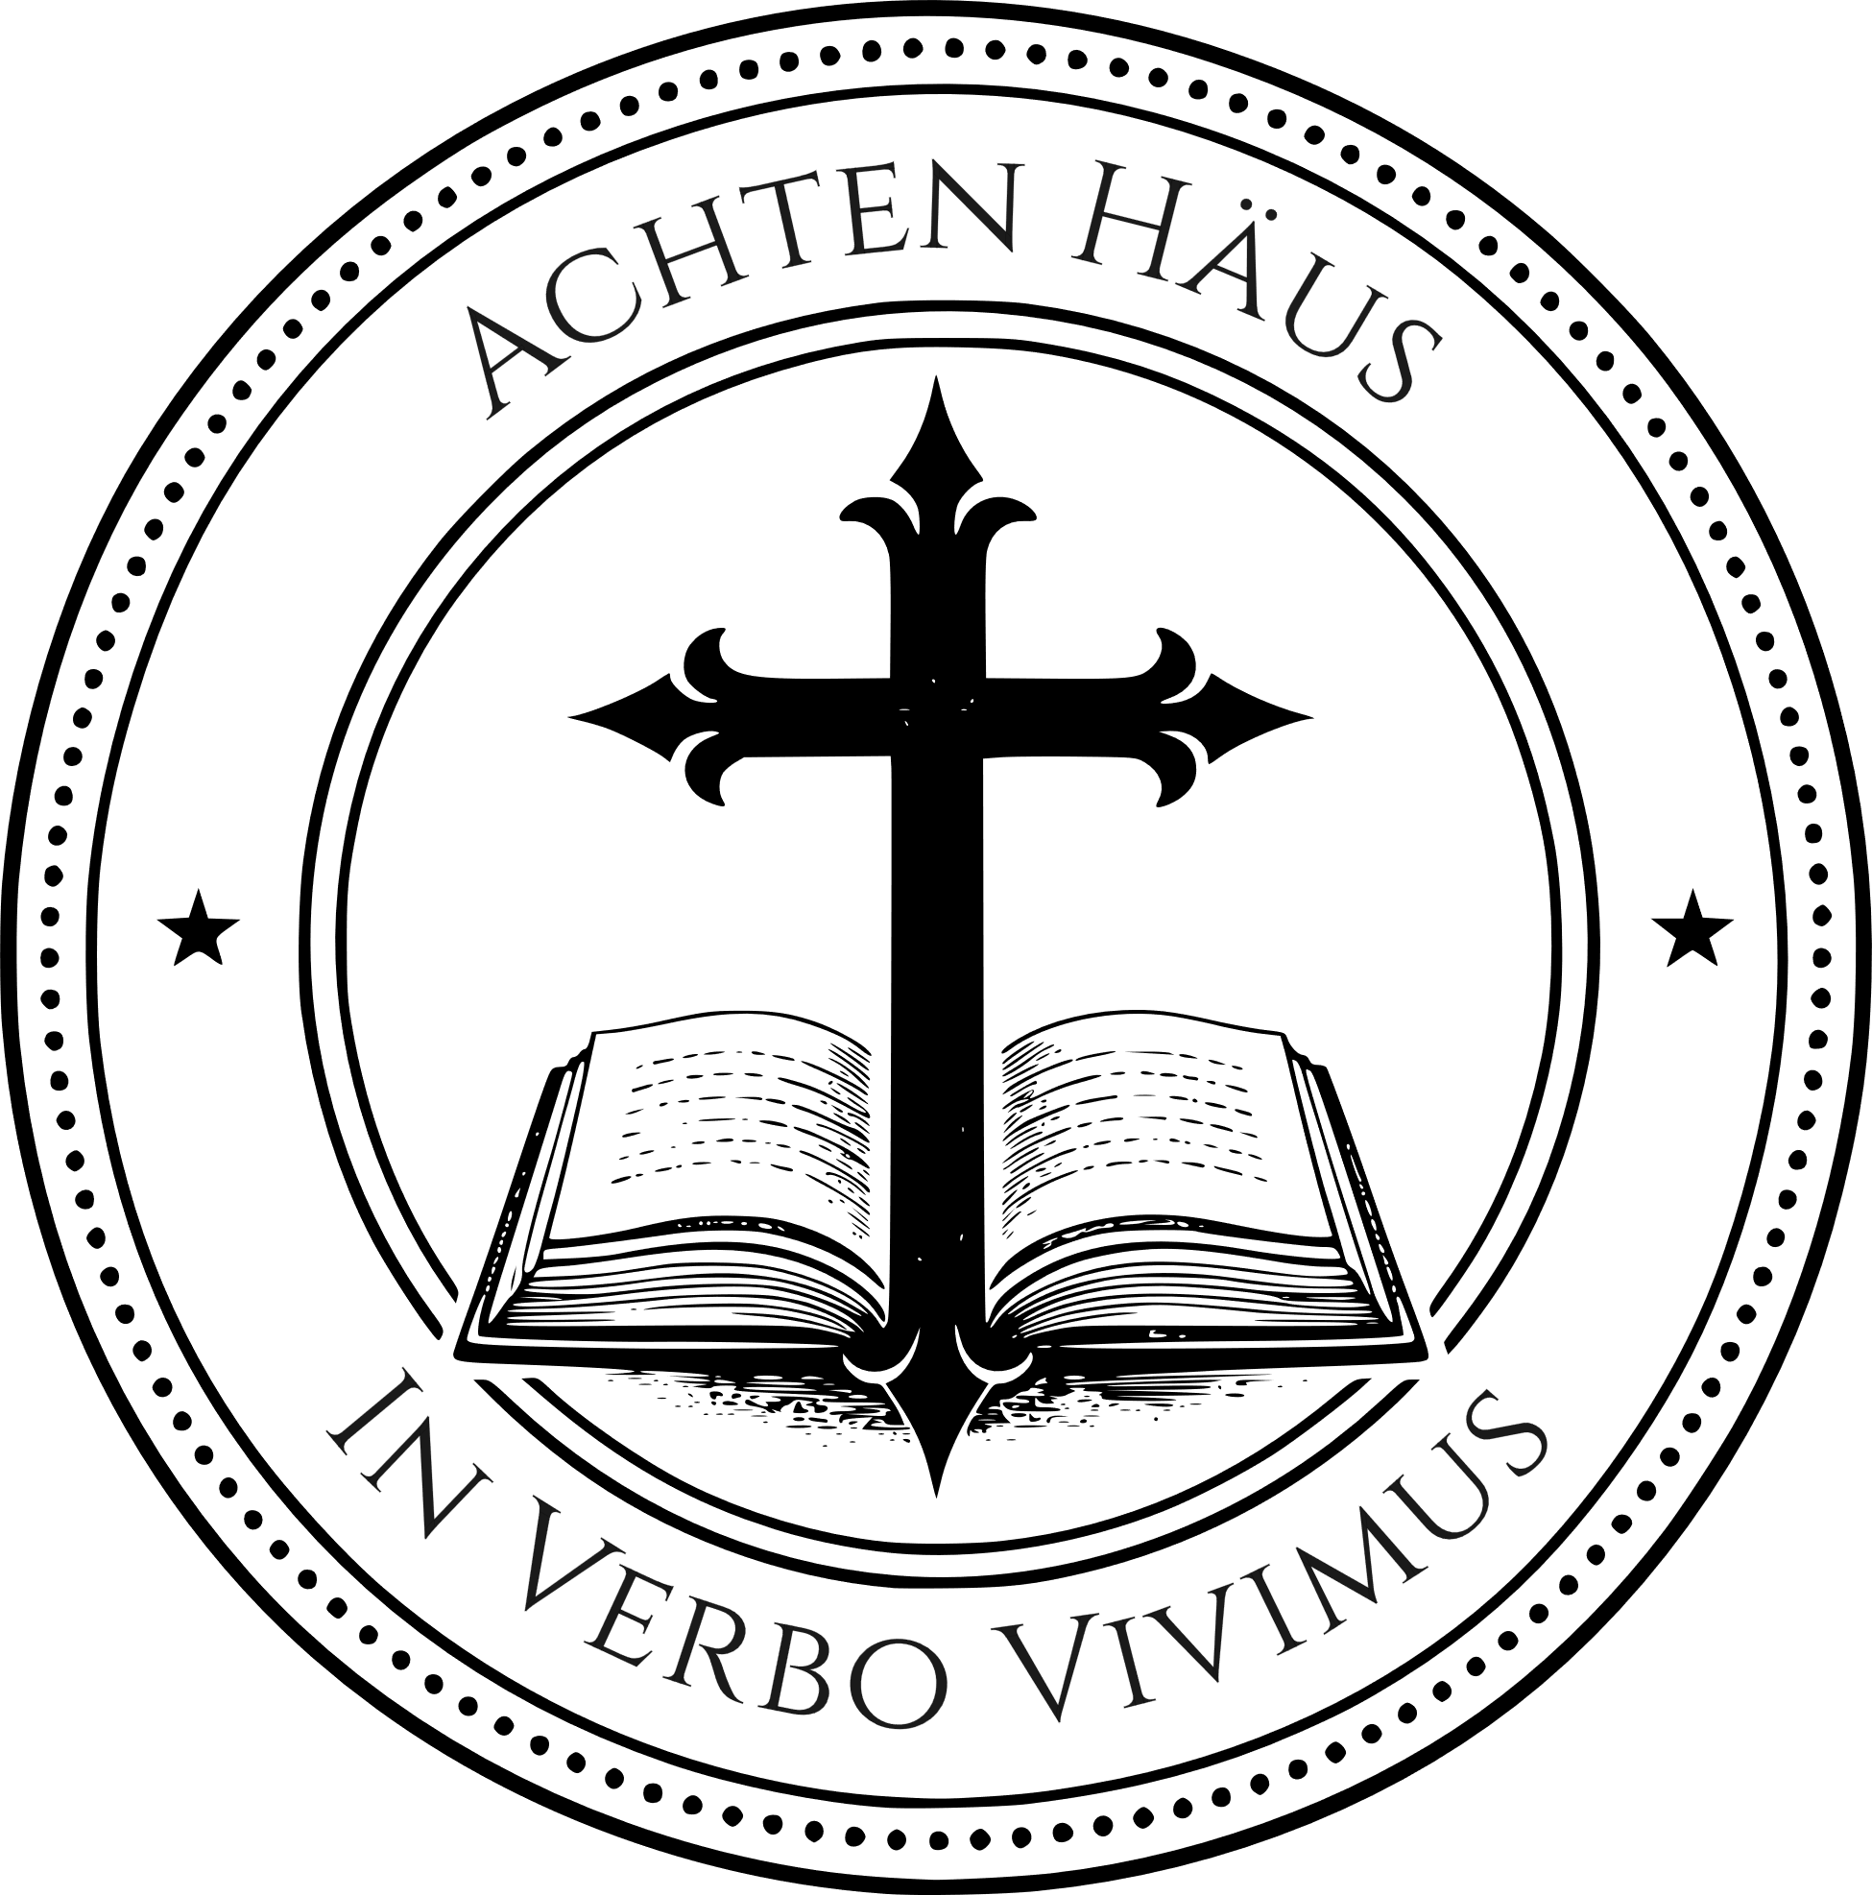
Achten Häus
Old Testament Apprenticeship Guide
Learning to live inside the story of Scripture

Old Testament Integration Project

Due Date: ____________________

Achten Häus – Old Testament Integration Project

This project is an opportunity to show what you have learned in the Old Testament course.

Your goal is not simply to repeat information.
Your goal is to show that you can:

- understand Scripture
- connect it to the larger story
- communicate it clearly
- respond to it faithfully

Choose one of the following project options.

OPTION 1 — EXPLAIN A PASSAGE

Choose a passage from the Old Testament and explain it.

Your project should include:

- what the passage says and how it is structured
- what the passage means in its literary and historical setting
- how it fits within the larger story and structure of the Tanakh
- what it reveals about YHWH, His covenant purposes, or the hope of the Old Testament

Format options:

- 2–3 page paper
- 5–10 minute presentation
- written teaching outline

OPTION 2 — TRACE A THEME

Choose a theme that appears across the Old Testament and trace it through several books.

Examples:
- Covenant
- Seed / offspring
- Kingdom and kingship
- Presence of YHWH
- Exile and restoration
- Messianic hope

Your project should include:
- where the theme appears
- how it develops
- why it matters

Format options:
- 2–3 page paper
- chart or map with explanation
- 5–10 minute presentation

OPTION 3 — TRACE A COVENANT

Choose one major Old Testament covenant and show how it develops within the larger story.

Your project should include:

- where the covenant is introduced
- what YHWH promises and requires
- how later Old Testament books develop it and how it shapes the Tanakh’s future hope

Format options:

- 2–3 page paper
- covenant chart with explanation
- 5–10 minute presentation

OPTION 4 — VISUAL STORY MAP

Create a visual project that shows the structure, movement, or message of the Old Testament.

Examples:

- a map of the Tanakh: Torah, Prophets, and Writings
- a narrative–poetry–epilogue structure diagram
- a covenant map from Noah through the New Covenant
- a theme or messianic-horizon map across several books

Your project should make the meaning of Scripture visible.

Format options:

- hand-drawn chart
- poster
- diagram
- digital visual with explanation

Include a short written or spoken explanation of what your visual shows.

OPTION 5 — LIVING THE STORY REFLECTION

Write a reflection on how this course has shaped the way you read the Old Testament and live inside the story of Scripture.

Your reflection should include:

- what you have learned
- what has challenged you
- what has changed in the way you read the Bible
- how you want to continue living inside the story of Scripture

Format:

- 2–3 page paper

PROJECT REQUIREMENTS

Whatever option you choose, your project should show:

- understanding of the text
- connection to the larger story
- clear communication
- thoughtful response

PROJECT GOAL

This project is not simply a final assignment.
It is an opportunity to show that you are learning to read, understand, and live inside the story of Scripture.

In Verbo Vivimus
In the Word we live

